StudySpot
Campus Study Place Finder

PROG2436 – Programming Mobile Application I

Final Group Project

Group1
Member 1: Hunter Choi
Member 2: Sambridhi Dhakal
Member 3: Anjana Maharjan

Instructor Name: Thomas Plathanath Mathew

━━━━━━━━━━━━━━━━━━━━━━━━━━━━━━━━━━━━━━━━━

1. Application Overview
StudySpot is a mobile application designed for college students in the Waterloo region to discover, save, and review study-friendly locations near campus. The app helps students find the best place to study based on amenities such as WIFI availability, power outlets, noise level, and operating hours.
Students often struggle to find a suitable study environment, especially during exam periods when libraries are full. StudySpot solves this problem by aggregating nearby study locations, allowing users to add their own discoveries, rate places, and view them on a map for easy.
1.1 Target Users
- College and university students in the Waterloo, Ontario area
- Students looking for quiet, well-equipped study spaces near campus
- Study groups seeking meeting locations with appropriate facilities
1.2 Key Features
- Browse and search study spots with filters (category, amenities, rating)
- View detailed information about each location including photos, ratings, and user notes
- Add new study spots with location, category, amenities, and personal review
- View all study on an interactive map with distance indicators
- Save favorite locations for quick access
- View real-time weather information to plan outdoor study sessions
- Persistent data storage using SQLite for offline access
━━━━━━━━━━━━━━━━━━━━━━━━━━━━━━━━━━━━━━━━━
2. Technical Specifications
2.1 Technology Stack
Component | Technology
Language | Dart
Framework | Flutter
Database | SQLite
Maps | Google Maps Flutter / flutter_map
REST API | Weather API, Places API, Map API
State Management | Provider / setState
HTTP Client | http / dio package
Target Platform | Android (Emulator + Physical Device)

2.2 RESTful API Integration
The application integrates with external RESTful APIs (JSON-based) to enhance the user experience with real-time data:
Weather API: Retrieves current weather conditions for the study spot’s location, helping students decide whether to study at an outdoor-friendly location or choose an indoor option.
Places API: Searches for nearby study-friendly venues (libraries, cafes, co-working spaces) and retrieves details such as address, category, and ratings. This provides pre-populated suggestions that users can save to their local database.
Map API: Provides interactive map tiles and marker functionality to display study stop locations visually.

2.3 Database Design
The app uses SQLite for persistent local storage. The database schema consists of two main tables:
study_spots table:
Column | Type | Description
id | Integer | Primary key, auto-increment
name | Text | Name of the study spot
category | Text | Type: library, café, co-working, outdoor
address | Text | Full address of the location
latitude | Real | GPS latitude coordinate
longitude | Real | GPS longitude coordinate
rating | Real | User rating (1.0 to 5.0)
amenities | Text | Comma-separated: wifi, power, quiet, food
notes | Text | Personal notes about the spot
image_path | Text | Local path to saved photo
is_favorite | Integer | Favorite flag (0 or 1)
created_at | Text | Timestamp

━━━━━━━━━━━━━━━━━━━━━━━━━━━━━━━━━━━━━━━━━

3. Screen Description

This section describes each screen of the application along with its corresponding mockup. Each screen description includes the purpose, widgets used, and event handlers implemented.

3.1 Splash Screen
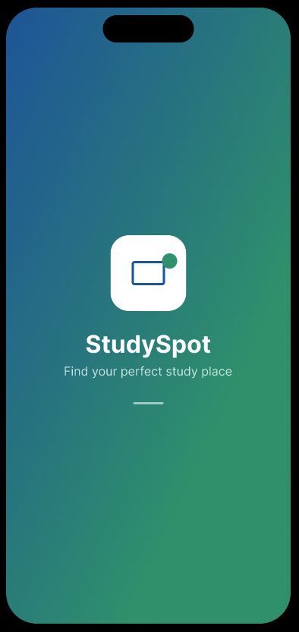 | Description
 | The splash screen is displayed for 2-3 seconds when the app launches. If features the StudySpot logo with a gradient background transitioning from blue to green, representing knowledge and growth
 | Widgets Used
 | Image(logo), Text, Container, BoxDecoration, Timer (auto-nav)

3.2 Main List Screen
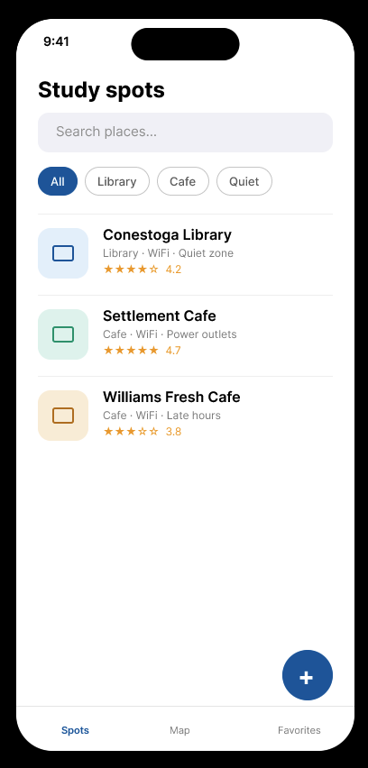 | Description
 | The main screen displays all saved study spots in a scrollable list. Users can search, filter by category, and tab any item to view details. A FAB button allows adding new spots.
 | Widgets Used
 | ListView, ListTile, TextField, FilterChip, FloatingActionButton, Icon, Card
 | Events

- onChanged (search text filtering)

- onSelected (category chip filter)

- onTap (navigate to detail)

- onPressed (FAB opens add screen)

3.3 Detail / Edit Screen
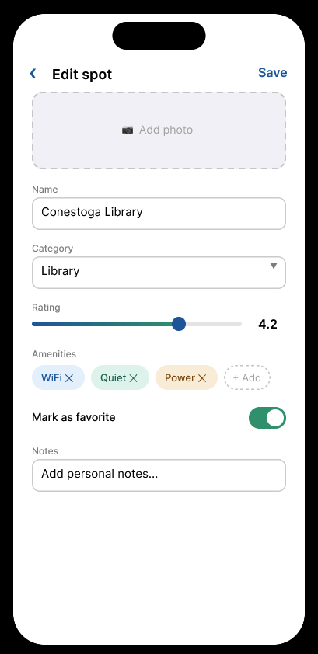 | Description
 | The detail screen shows full information about a study spot and allows editing. Users can modify the name, category, rating, amenities, and notes. Real-time weather data is fetched via API.
 | Widgets Used
 | TextField, DropdownButton, Slider, Chip, Switch, ElevatedButton, Image, DatePicker
 | Events

- onChanged (text fields, dropdown, slider)

- onDeleted (remove amenity chip)

- onChanged (favorite switch toggle)

- onPressed (save or delete to SQLite database)

- API call (fetch weather data on load)

3.4 Map Screen
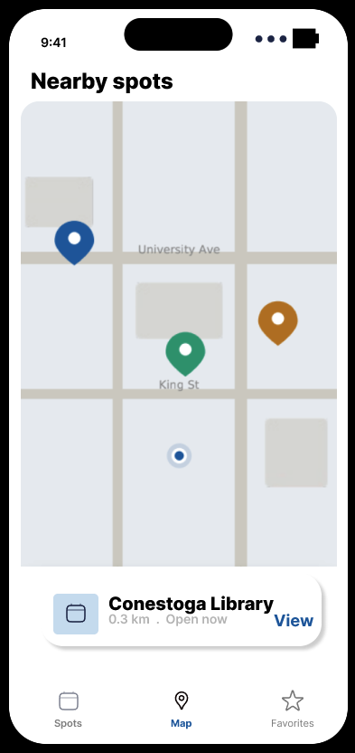 | Description

The map screen displays all saved study spots as color-coded markers.
- Blue = Library,
- Green = Café,
- Amber = Co-working.
Tapping a marker reveals a bottom sheet with spot details and navigation option.
 | Widgets Used
 | GoogleMap / FlutterMap, Marker, BottomSheet, Card, ElevatedButton
 | Events

- onTap (marker, show bottom sheet)

- onPressed (navigate to detail screen)

- onMapCreated (Initialize map controller)

3.5 Favorite Screen
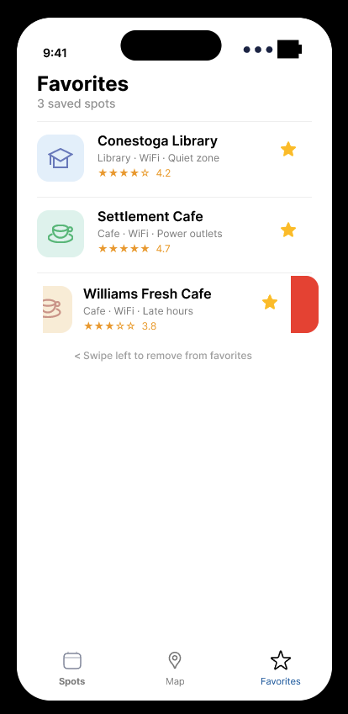 | Description
 | The favorites screen shows bookmarked study spots. It uses the same list layout but filtered to only show favorited items. Users can swipe left to remove a spot from favorites using the Dismissible widget.
 | Widgets Used
 | ListView, ListTile, Dismissible, Icon, SnackBar
 | Events

- onTap (navigate to detail screen)

- onDismissed (remove from favorites)

- SnackBar with undo action

3.6 All Screen Overview

The following image shows all five screens side by side for a comprehensive overview of the application’s user interface.
 |  | 
 | 

━━━━━━━━━━━━━━━━━━━━━━━━━━━━━━━━━━━━━━━━━

4. Navigation Structure

The application uses a BottomNavigationBar with three tabs as the primary navigation pattern:
- Spots – Main list screen showing all study spots
- Map – Map view of all spots with location markers
- Favorites – Save/bookmarked study spots

Secondary navigation uses stack-based Navigator.push() for navigating from the list or map to the Detail/Edit screen and the Add New Spot screen. This provides a natural back-button experience.





